**585347**

11

**System Analysis D1 D2**

**Kieran Foxley-Jones**

Contents

Why do projects Fail 3

How can we avoid failing 3

Project Life cycle 4

Critical Path Analysis (CPA) 4

My examples 4

Prototype One 4

Movie.addRating() 4

Potential risks of my implementation 4

# Why do projects Fail

Projects can fail for a number of reasons, many through your own fault, and others through a clients fault, or another member of your team.

Feasibility of the project is paramount, is it possible to create? Its sounds like a simple question but it is the most critical, if the system the client wants is not feasibly, or even if it is feasibly, but not on the timescale and/or budget the project has, could kill the project straight away. The budget and timescale are also of paramount importance, the project needs sufficient budget for it to live on, and a realistic timescale. These affect large and small projects, from a simple information website, to national IT Project spanning a whole country.

Projects from their outset are developed to the requirements of yourself or your client’s demands; they will outline some kind of expected end project, and have a scope to what is to me included. This would be classed as the project scope, what is to be created and developed to end up with the finished project. Without specific requirements for the project to achieve, there can realistically be no finished project that will be sufficient on completion, because you will not truly know just what your system should be. Lack of client input can also kill a project, as it develops the client may have one vision of what it is your creating, and you may have another. If you don’t communicate with the client on a regular basis, these two visions may start to seriously diverge to the point that you are developing something that is not wanted.

This Scope could be initially far too large to realistically develop within the time allowed, requiring far too much development to be feasible. Scope Creep can also be a common issue, clients can change their mind on what they want their system to be, or even forget to tell you about a feature want when the Proposal and Analysis aspect of the project happens.

Poor testing of the project can make or break it, you could find towards the end of the project that relatively simple tests are failing because there has been no validation implemented into the system, cause simple inputs to break, or even more serious cases with the use of SQL Injection. This can cause serious security issues, and if design and development time are not considered or is allowed for during the projects lifetime, could cause serious issues. Even a test SQL injection attack could destroy months of work on a database which is critical to the project, especially so if it is tested on a live database.

Lack of change control can also effect a projects life, businesses change and generally a IT project is a major undertaking and can possibly take so much time, that new technologies and developments happen both inside and outside the business can happen and they could overtake your project requiring you to change. Lack of change control may stop you from adapting your project to the new needs of the client, new development languages or techniques that are incompatible with your own development requiring a complete rewrite or even the killing of the project.

# How can we avoid failing

With regards to scope, a good initial understanding of the requirements of the system is essential, this will allow you to scope the project, and make sure important aspects of the system are prioritised and time allowed to design and develop them. You can also cut off unimportant features that are unnecessary or completely irrelevant to the requirements. A good scope will also affect Scope Creep, once you have your scope, and know what you are to required to create, you will be able to write that scope into the contract and have your client agree to it and sign it. This allows you to either rule out any new features the client desires, or implement them with the requirement of extra funding and time to create that feature.

When you know the scope of the project, you will be able to accurately analyse existing systems that are to be replaced/enhanced through your project, giving you a better understand of just what it is you are creating. This will also affect your design of the system.

Contracts are important to a project, no matter how large or small. A good solid contract is essential as it allows you to set boundaries on just what it is you are to create, locking in the scope of the project and instantly settling disputes when new features are requested. A contract is also essential with regards to when payments are made; a long project could have multiple phases through its lifetime, with deliverables expected on specific dates. Contracts can define when those dates are, and what deliverables are expected, so the developer can deliver them to the client and expect payment. If the developer hits the deadline with the deliverable expected, and the client decides not to pay as expected, the contract can force them to pay what they should when they should.

# Project Life Cycle

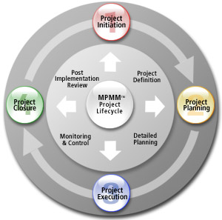A projects life cycle generally goes through a number of stages

Project Initiation will consist of defining what the project will be and do what the requirements are, what the scope is and any analysis that is necessary.

Planning will consist of any research necessary for the project, detailed design of the system to be created

Execution will consist of development of the system, any small changes to the design, creation of the systems and design of the test plans.

Closure of the project will include the testing of the system, and implementation of the system to the client. Evaluation of the created system will also occur here. After this the cycle may repeat, this basic system can be part of an existing project methodology and be repeated over and over again for specific features.

# http://1.bp.blogspot.com/_ZTG0gAdd1k8/TC8gxKz7GzI/AAAAAAAAAhA/dNLBXyHxDrs/s1600/project_gantt_chart+(1).gifCritical Path Analysis (CPA)

CPA allows you to determine when certain tasks should be started, and when they should realistically be completed. This also allows you to plan when tasks finish and when tasks that require the completion of the previous one, can start. For example, to create a website that uploads photos to a website, their location and information to a database and outputs those to a webpage using a unique use login. You cannot realistically develop the web page until the previous constituent parts as it will be dependent on them. You really want to create the database first, develop all the relevant tables for the photos, their location, information etc, user information and password tables. This will allow you to then develop the user login and registration system, then the uploading system, and finally the outputting system.

CPA allows you visually draw this out with a timescale attached, much like a Gantt chart but with a more visual flow to it:

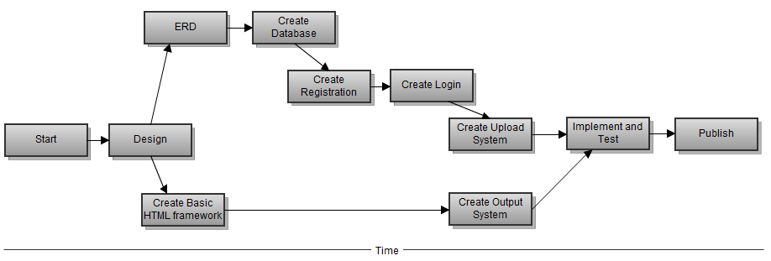

# 

Gantt chart

# My Example

## Movie.addRating()

When researching the feasibility and features of the TMDB.org API for my analysis of Prototype Two, I came across a feature within the API that allowed my website to upload user ratings from my site, to the API, affecting the ratings on the TMDB.org site. This seem like an essential system to implement, and as users review and rate movies on my website, the ratings change and the outputs of top 10 scripts on my site would theoretically change. This function avoided the potential of needing to store, and access the rating data from my own database, and also update the TMDB.org’s site with relevant data.

Whist designing prototype two, I had this feature firmly in my mind, and even went so far into the design that I started to develop a rough framework of the website using the API. When it came to do a rough implementation of the addRating function, I found that its requirements were not what I thought. It required a unique user to log in, not only on my website, but also onto the TMDB.org to allow them to upload their rating to TMDB.org. This involved using my website API Key to create a token, which then created a valid Session ID for TMDB.org. But to do this required my site to redirect the use to TMDB.org for the login. Although it was a powerful function, and I could implement it, it did not feel elegant moving from one site to another and back again.

# Potential risks of my implementation

There is a major issue with my current developed project, it is beholden to TMDB.org for all of the movie information and movie ID’s. My reviews stored within my database, are linked to movies through movie ID numbers, using those numbers I can use the TMDB.org API to pull relevant information from it and output that information to my web pages using PHP scripts. When it works, it works spectacularly well, however when the API goes down for any reason, my whole site ceases to function, causing PHP and MySQL errors throughout the site rendering it impossible to even get any information to display. The most that displays is the header and logo, and login form and that is it.

The problem also extends to testing of the site, if the API is down, I cannot work on small unrelated features because of all the missing information required.

This of course is a serious issue to my project, as from the outset I developed it to potentially be published and used, but if I cannot find a way to work around this issue, it may never happen, although it is workable for just an IT project.

One potential workaround is to cache any information that I receive from the API to my own database, so my PHP scripts pull the information from my database rather than the API if there is an absence of access to the API or even if the information does exist in my database, accessing it from there will take less time and less bandwidth than if I were to use the API.

# Project Plan Effectiveness

The plan for this project involved many different aspects and was for me a learning experience, it was the first time I had created a plan and stuck to it as best i could, and it did have some problems. From the start of Prototype One the plan was to create a basic site that would allow the creating of a user that then could upload a typed review to the website, and then have that review output correctly to the relevant movie’s web page. This in itself was a learning experience with regards to PHP and MySQL, as my knowledge with both languages was very basic at the start of planning, I created a plan that emphasised the development of the scripting behind the prototype, over the development of the visual front-end. This allowed me to focus on learning the skills needed to create the systems I had planned out.

One example was the creation and inclusion of using security Hashing on user input passwords, adding a Salting string to that hash and then hashing and ultimately storing the resulting string within the database. This was only an idea I had read about and never put into practice before the Plan, and yet I decided to include it. This plan then allowed me the time to actually learn and then implement the needed code into the site.

Prototype Two’s plan was to initially separate the code that runs the various elements of the website away from the layout of the site itself, allowing me to create a layout that could be used in multiple pages without each page being massively different, basically creating template that I could then fill in the gaps with PHP function calls, allowing for a consistent look throughout. This plan work to an extent, as out of the three distinct pages (Index, Movies, Title), two barely had any differences between them, apart from a few lines calling different functions. Title however never ended up in a separated state like Index and Movies, mainly due to time issues, and the page itself contained a lot of the code necessary to output its content. Although the layout framework for the page is the same as Index and Movies, I feel that Title needed the content generation scripts to be moved into their own Class.

Prototype Two’s plan also focused on the inclusion and implementation of the TMDb.org API, a feature that I had played around within the time between finalising Prototype One and starting planning for Prototype Two.

The plan was to implement multiple functions from the API into the website, including one function called Movie.addRating() which i believed at the time of planning would allow me to upload review ratings from my website to the API, affecting the API’s database and movie ratings, which would in turn effect my website’s top ten movies output. When it came time to implement this function, I quickly found that it would require sending the user from my website, to the TMDb.org website and need them to login there to submit a single rating on my site. This feel very cumbersome to me, as I would not be able to cleanly send people to TMDb.org for login and then bring them back, this would also cause issues with keeping movie ratings the same between both websites. The solution I came up for this was to store the rating myself, simple enough, but it happened at a late stage, and if completely implemented would cause a rewrite on a couple of my already implemented functions.

This was caused by a failure to properly research the function, and assuming it worked the way I initially believed it did, I should have paid more attention to it and planned accordingly, this would have given me the time needed to implement my own rating system before my deadline loomed.

# Process Implementation

Throughout the development of the website, I used a spiral model of prototyping to help me analyse, design, develop and evaluate each prototype, allowing me to make changes to a design or even make a new design base on the evaluation and analysis of a prototype. This can be seen throughout my whole project as each prototype went through this process; I felt that it was an easy development process to work with giving me a goal at each point of development.

There were issues, for example working with, and for myself required me to give myself specific deadlines to work to, deadlines that I wasn’t sure were sufficient enough. For some parts of the process I gave far too much time to complete analysis for prototype one was given 2 weeks to down, when really for a basic prototype only required a couple of days of analysis of external sites. I gave the same amount of time to the analysis of Prototype One for Prototype Two, which in the end took longer that I had planned, requiring me to eat into time I had earmarked for Design.

An improvement to the process would be to allow it to be flexible, maybe apply the Spiral methodology to smaller parts, have an quick analysis, design, development and evaluation spurt, then focus on individual components developed and do a quick Spiral process on each, a similar system is used on the Scrum Methodology, where a work backlog of small constituent parts is worked out, and the Spiral like process is implemented on those parts in turn.

No matter what methodology you use, it is paramount that something is used to structure the development of a system, giving you clear goals on what is required of you at each time, regardless of whether it is a personal project, or a massive multinational undertaking.